**Requirements Specification**

**Document**

**Authors: February 22, 2019.**

**Group 6:**

**1.Nishad Aherrao**

**2.Alexander Windeler**

**3.Bishesh Shrestha**

**4.Khom Sitaula**

**5.Shivangi Vyas**

**1.a. Use Case Stick Figure Diagram**

Note: There are total of 3 use cases Client-Server, Server-Client, Admin-server

1. Client - Server Usecase

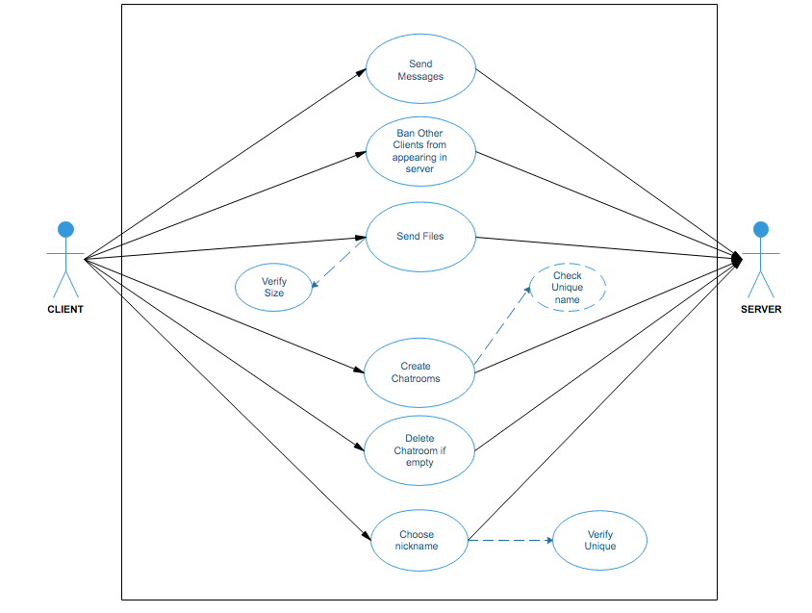

2. Server - Client Usecase

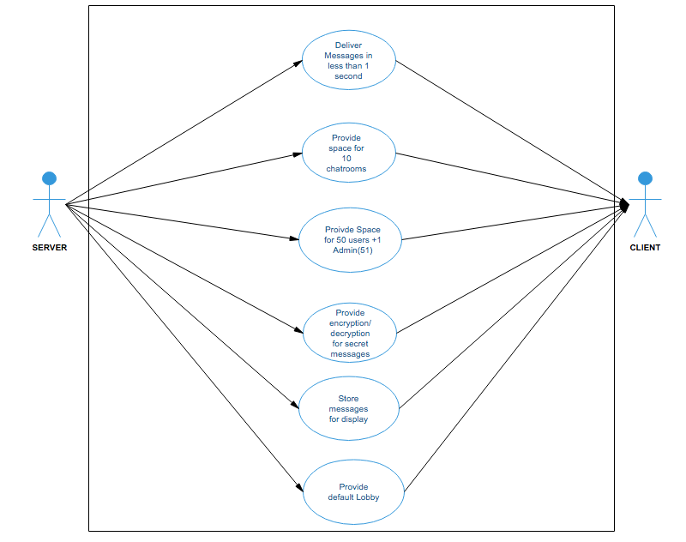

3. Admin - Server Usecase

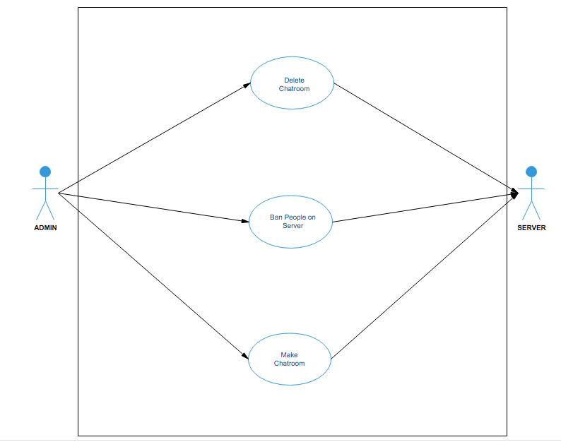

**1.b. Tabular Use Case Description**

|  |  |
| --- | --- |
| Client-Server | Transfer data |
| Actors: | Clients, Server |
| Description | Clients use superchat to send messages and file and transfer data to the server. The file size will be checked and only the files with limited size will be transferred. |
| Data: | Text messages, files |
| Stimulus: | User command issued by client |
| Response: | Confirmation of message being sent. |
| Comments: | Clients need to be in a chatroom to transfer data. |

|  |  |
| --- | --- |
| Server-Client | Providing chat room and lobby |
| Actors | Server, Client |
| Description: | The server should provide space for 10 chat rooms for 50 clients. |
| Data | Text messages and files |
| Stimulus: | Client need to login |
| Response: | Once the server provides the client with the chat room , they should have the access to send messages inside the chatroom. |
| Comments: |  |

|  |  |
| --- | --- |
| Admin-Server | Creating a chat room |
| Actors | Admin/ Server |
| Description: | Admin creates a chatroom in the servers. They can ban people and delete the chat room. |
| Data: | Chat room name, nicknames for banning |
| Stimulus | User commands by the admin |
| Response: | Chatroom is created |
| Comments: |  |

1. **List of Requirements**

|  |  |  |  |  |  |
| --- | --- | --- | --- | --- | --- |
| Identifier | Requirement | N/F | Source | C/S/B | Notes |
| 1 | Messages delivered in less than 1 second from being sent | N | Document | C |  |
| 2 | Maximum of 50 users online at one time and an admin. | F | Document | S | Admin doesn’t count in the 50 users. |
| 3 | User ability to create both public and private chat rooms | F | Self Decided | C |  |
| 4 | SuperChat runs on the linux operating system. | N | Document | B |  |
| 5 | SuperChat will be implemented using -std=c++11 | N | Document | S |  |
| 6 | User can delete empty chat rooms | F | Document | C |  |
| 7 | User provides nickname to be used in chat rooms, can be changed every log in | F | Document | C |  |
| 8 | SuperChat must have two applications, The “Client” and the “Server”. The Client and the Server can run on the same or on different computers. | N | Document | B |  |
| 9 | User can place others on personal ignore lists to stop seeing messages from them | F | Document | C |  |
| 10 | SuperChat admins can ban users from the chat service | F | Self Decided | S |  |
| 11 | User can use multiple clients at once, as long as they have different nicknames | N | Document | C |  |
| 12 | The user interface for the Client will use the ncurses. | N | Document | C |  |
| 13 | The server will provide a user that just joins a chatroom all of the previous messages. | F | Document | S |  |
| 14 | Chat room will record all messages sent until deleted. User will receive all messages sent when joining the room | F | Document | S |  |
| 15 | Ten chat rooms can exist at one time, including the lobby | N | Document | S |  |
| 16 | Messages will be spell checked against a file provided by the instructor. The dictionary will have one word per line, and will not be in any order. | F | Document | S |  |
| 17 | Messages sent will include the nickname of the person sending and a time stamp | F | Self Decided | S |  |
| 18 | ‘Tab completion’ will be used on the client. Suggest the gnu readline library be used.. | F | Document | S |  |
| 19 | Persistent information stored across client invocations will be stored in a file named “~.SuperChat”. | F | Document | S |  |
| 20 | Files can be transferred between users between their home directories. | F | Document | C |  |
| 21 | Files can be transferred between users between their home directories. | F | Document | S |  |
| 22 | There is no maximum for users per chatroom as long as there are 50 or less users online at one time. | F | Self Decided | S |  |
| 23 | “Message obfuscation” will be supported. An integer, known to clients, will be used to obscure the meaning of the message for clients that don’t know the number. (technique must be very simple!!) | F | Document | S |  |
| 24 | The maximum size for files to be transferred is 50 mb | N | Self Decided | B |  |
| 25 | There is a default chat room called the ‘lobby’. It can not be deleted. | F | Document | S |  |
| 26 | The client and server must function without failure for at least 30 minutes. | N | Document | B |  |
| 27 | A given client can ‘ban’ others from being displayed. | F | Document | C |  |
| 28 | When SuperChat runs. It will bring user to a login page where user can enter nickname and will be logged in if there aren’t 50 users online already. If there are 50 users online then it will pop an error message saying that SuperChat cannot accept any more users at the moment. | F | Self decided | C |  |
| 29 | When SuperChat runs. It will bring user to a login page where user can enter nickname and will be logged in if there aren’t 50 users online already. If there are 50 users online then it will pop an error message saying that SuperChat cannot accept any more users at the moment. | F | Self decided | S |  |
| 30 | A button to create or delete chat room | F | Self decided | C |  |
| 31 | There should be two buttons; leave and logout; leave will bring the user back to lobby and logout will bring the user back to the login page | F | Self Decided | C |  |
| 32 | Common replies will be saved and used to help users ‘auto reply’. | F | Document | S |  |

**3.Sate Diagram of Runtime Behavior**

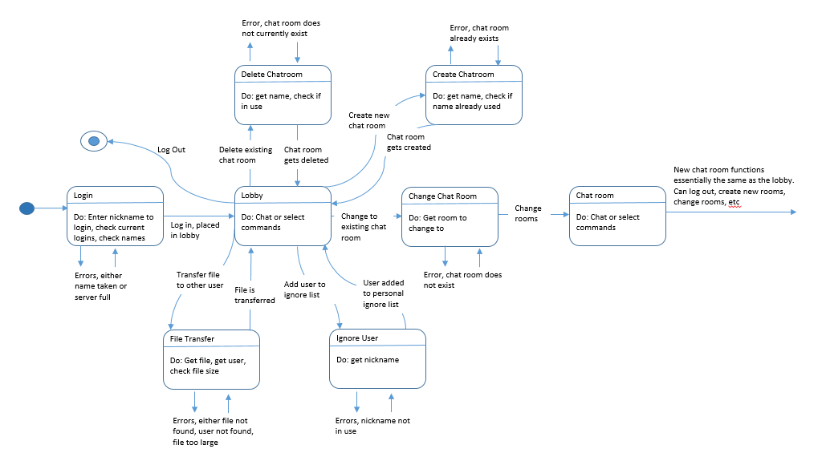

**4. User Interface Mockup**

1.The first screen a user sees when he starts the program

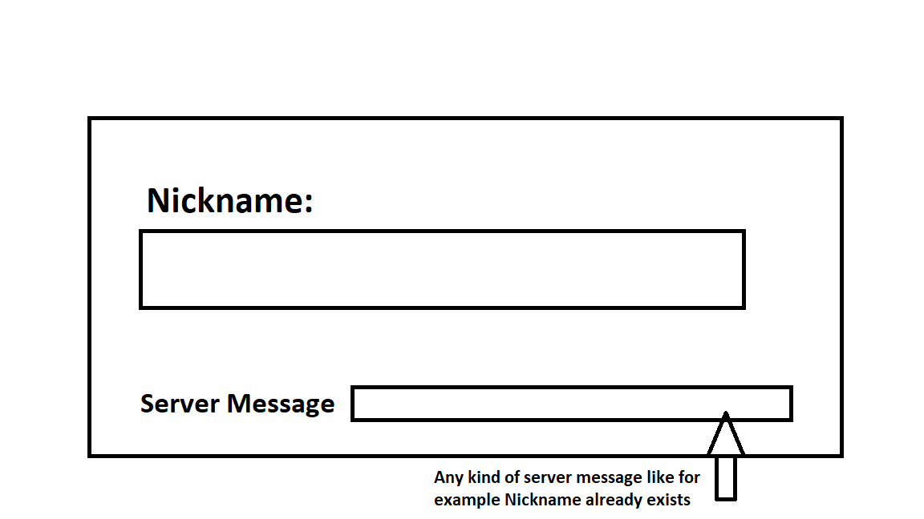

2. The main screen of the program that has all the features needed displayed as functions in form

Buttons shown below.

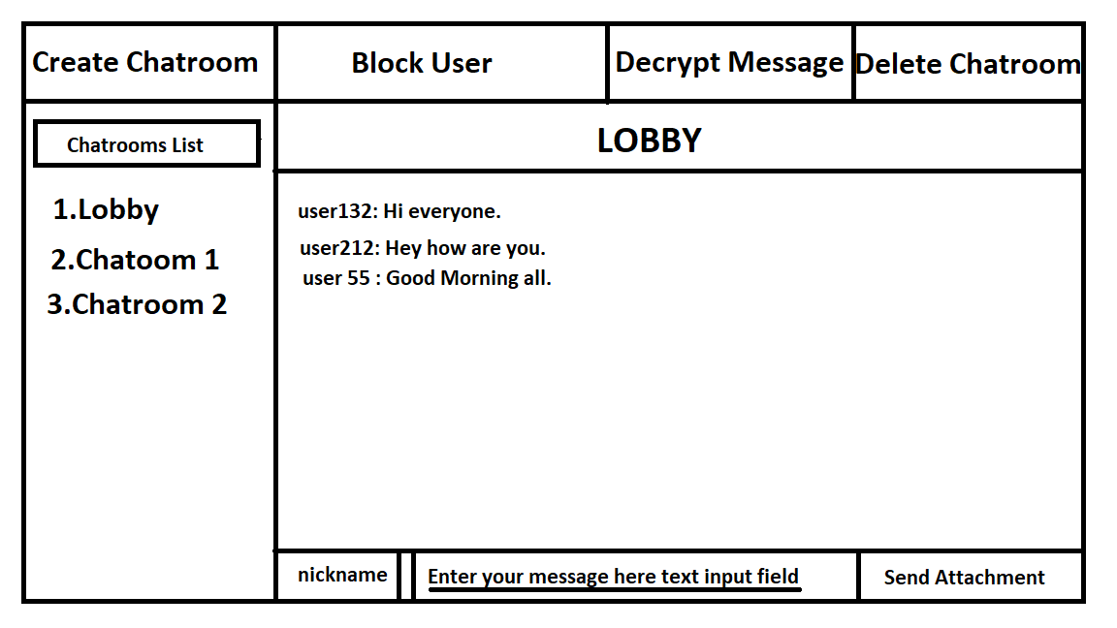

**Note: All the following windows popup based on which button you click on window 2.**

3.

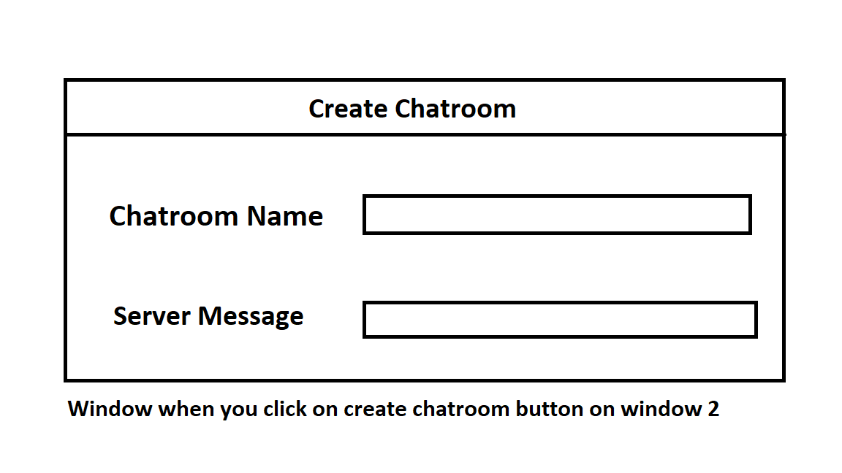

4.

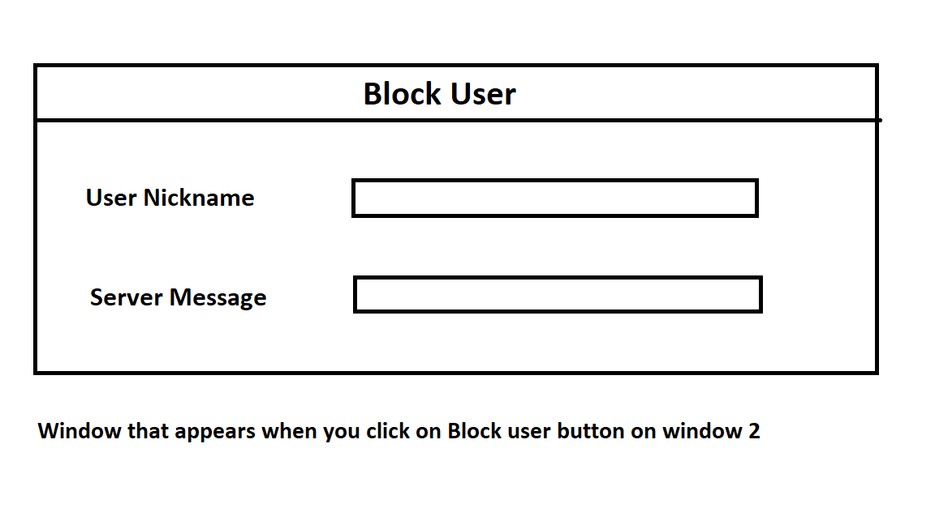

5.

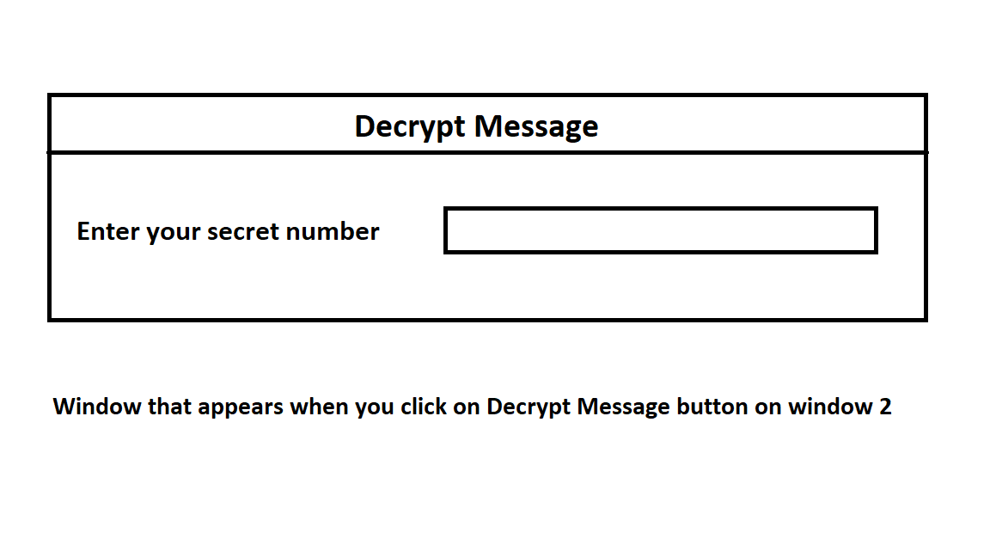

6.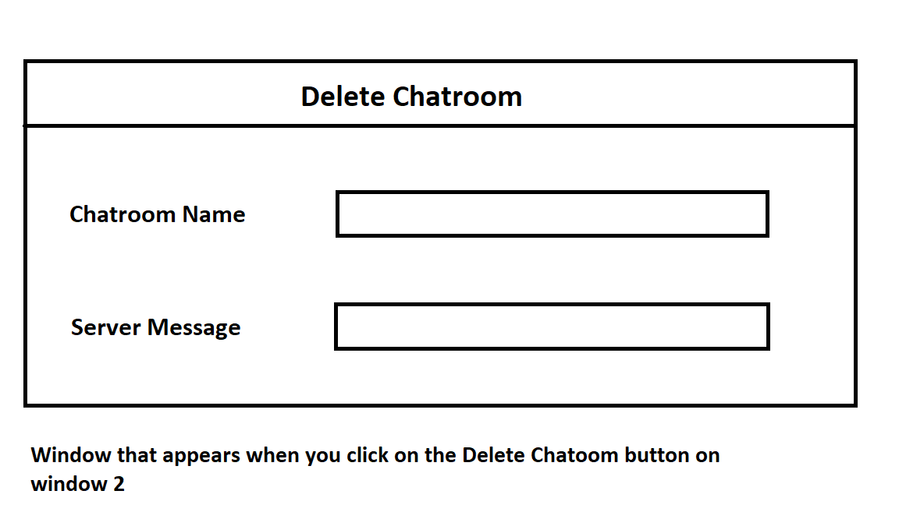

**5.. A list of unknowns or TBD’s.**

1. Acceptable file size for attachments.
2. User can change the colors of the background / any other user customization.
3. User can send emojis.
4. Users can give a name to their chatroom.
5. Users can nudge/poke each other?
6. Show number of users online in the current chatroom?
7. Notify other users that someone left/joined the chatroom?
8. User Interface for the Attachment feature?